WEEK 7

Mandatory Hands-On

**REACT**

**Creating a tickietbookingapp Application**

* *Ticketbookingapp* application is created in the directory Week7\ using the command *npx create-react-app Ticketbookingapp.*

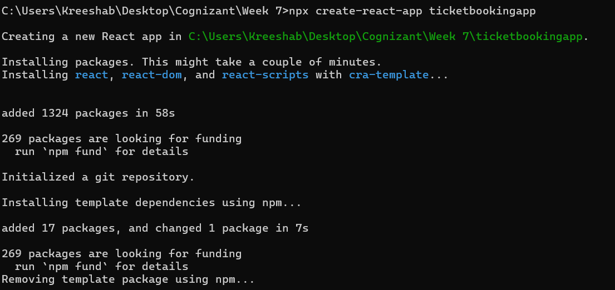

* Navigated to the React app and created UserPage and GuestPage Components inside components folder in src.

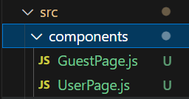

**GuestPage.js:**

import React from 'react';

function GuestPage() {

  return (

    <div>

      <h2>Please Login</h2>

    </div>

  );

}

export default GuestPage;

**UserPage.js:**

import React from 'react';

function UserPage() {

  return (

    <div>

      <h2>Welcome User!</h2>

    </div>

  );

}

export default UserPage;

**App.js:**

import React, { useState } from 'react';

import GuestPage from './components/GuestPage'; // no curly braces

import UserPage from './components/UserPage';

function App() {

  const [isLoggedIn, setIsLoggedIn] = useState(false);

  const handleLogin = () => setIsLoggedIn(true);

  const handleLogout = () => setIsLoggedIn(false);

  return (

    <div>

      <h1>Ticket Booking App</h1>

      {isLoggedIn ? (

        <>

          <button onClick={handleLogout}>Logout</button>

          <UserPage />

        </>

      ) : (

        <>

          <button onClick={handleLogin}>Login</button>

          <GuestPage />

        </>

      )}

    </div>

  );

}

export default App;

**Index.js:**

import React from 'react';

import ReactDOM from 'react-dom/client';

import App from './App';

const root = ReactDOM.createRoot(document.getElementById('root'));

root.render(<App />);

**Sample Output:**

